SQL - Pizza Hut Sales Analysis

Introduction :

* The analysis will utilize data to examine sales figures, customer demographics,product preferences,and other relevant metrics to inform strategic decisions .
* The primary objective of a pizza hut sales analysis is to understand sales performance , identify trends , and ultimately improve business operations.

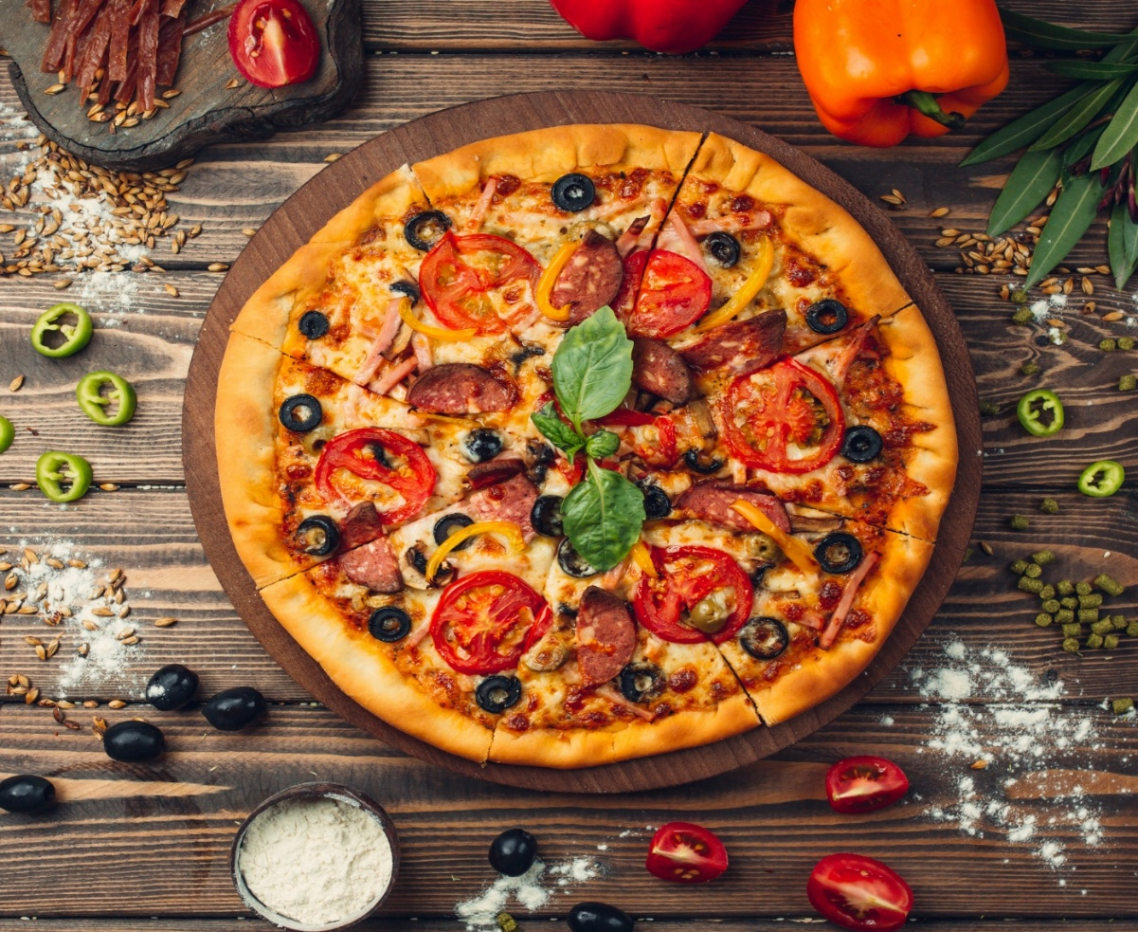

Problem statement :

* In this project, problem statement is to understand pizzahut’s sales performance, identify areas for improvement, and develop strategies to enhance profitability and market share in areas.
* This includes identifying peak sales periods, popular menu items,customer preferences.

The project aims to provide actionable insights that support strategic decision-making in areas such as inventory management, marketing , and staffing.

Dataset description :-

* This dataset contains sales data for pizzahut , typically includes detailed information about pizza orders,pizza specifics, and order timing.
* Key columns often include order_id, pizza_id, quantity,order_date,order_time, price, pizza_size, category, ingredients, and pizza_name. this data enables analysis of sales trends , customer preferences, and revenue generation.

Q1 : Find the total number of orders placed

Query :

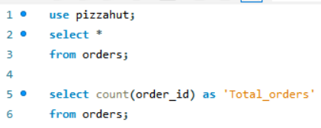

Output :

Q2 : calculate the total revenue from pizza sales

Query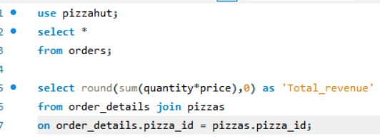 :

Output :

Q3 : identify the highest-priced pizza.

Query :

Output :

Q4 : Most ordered pizza size

Query :

Output :

Insights :

* Large pizza Dominance : the large pizza size is the clear winner , generating the highest revenue and selling the most quantity..
* While medium and small sizes also perform well, there is a sharp decline in both revenue and quantity sold for extra-large and XXL sizes.

Q5 : Top 5 popular pizzas

Query :

Output :

Q6 : calculate the Total quantity ordered for each pizza category

Query :

Output :

Q7 : Order trends by hour

Query :

Output :

Insights

* the busiest hours for pizza orders are between 12PM and 1PM which is lunch time and also between 5Pm and 6PM are the busiest hours for pizza orders.
* These periods likely represent high demand due to people’s schedules and preferences for meals.

Q8 : pizza distribution by category

Query :

Output :

Q9 : Average Daily pizza orders

Query :

Output :

Q10 : Top 3 pizzas based on Revenue

Query :

Output :

Q11 : Revenue contribution by pizza type

Query :

Output :

Q12 : cumulative Revenue over time

Query :

Output :

Q13 : Top 3 pizza Types by Revenue in each category

Query :

Output :

**Insights :**

* Peak hours : The busiest hours for pizza orders are between 12PM and 1PM which is lunch time and also between 5Pm and 6PM are the busiest hours for pizza orders.
* Top selling items : thai chicken_pizza, barbique_chicken_pizza, california_chicken_pizza are the top pizzas.
* Order frequency ,customer behaviour, customer retention are the different insights. Online and offline sales are different in volumes and revenue.
* Sales patterns during holidays, summer, or special events may changes.
* Large pizza size generating the highest revenue and selling the most quantity..

**Recommendations :**

* Adjust menu offering based on sales data and profitability.
* Focus marketing efforts on high-value customer segments.
* Optimize inventory levels based on demands patterns.
* Collect and act on customer feedback to improve menu and service.

These insights can help pizza hut make data-driven decisions to boost sales, improve customer satisfaction, and increase profitability.

Thank you : )